Paper on measuring water level using a capacitive probe.

Following on from the meeting on the 16May17 I did some on-line investigations and then circuit modelling using iCircuit (electronic circuit simulator that runs on a Mac).

Terry had mentioned Schmitt triggers during our meeting, that sparked a thought as they are something I’ve used, in the dim distant past, as clocks in non-critical digital circuits. The circuits I designed, way back then, used a TTL Schmitt inverter IC but you can also brew your own using an OpAmp and a couple of resistors. So I lashed up the following oscillator circuit from stuff I had lying around:

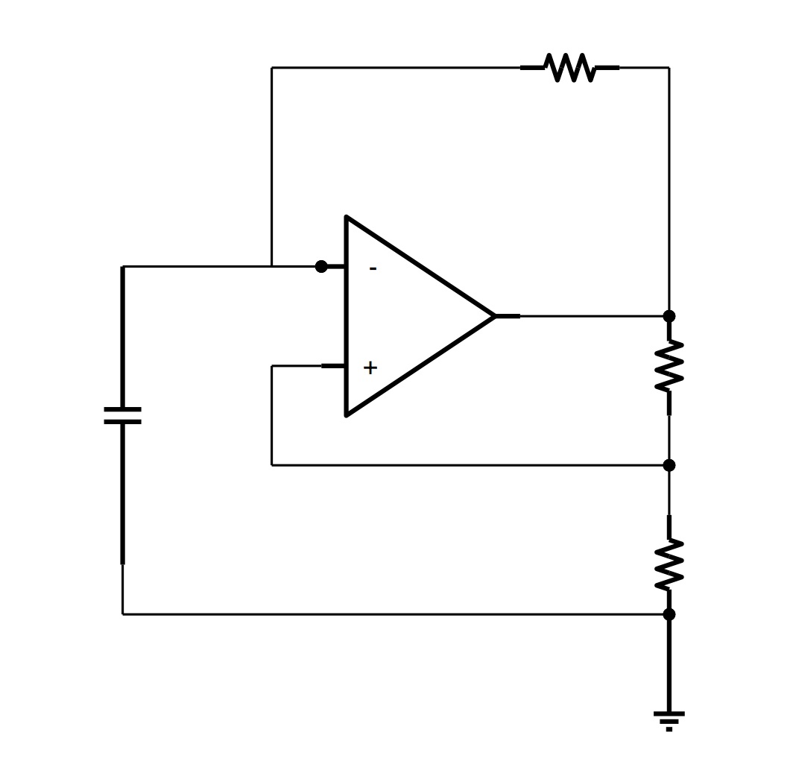
(apologies for the lack of detail on the diagram, I haven’t got the hang of Libre Office yet)

The circuit oscillators with nice square wave with a frequency driven by the feedback resistor and capacitor. The capacitor shown is the water level probe which looks as below in real life:
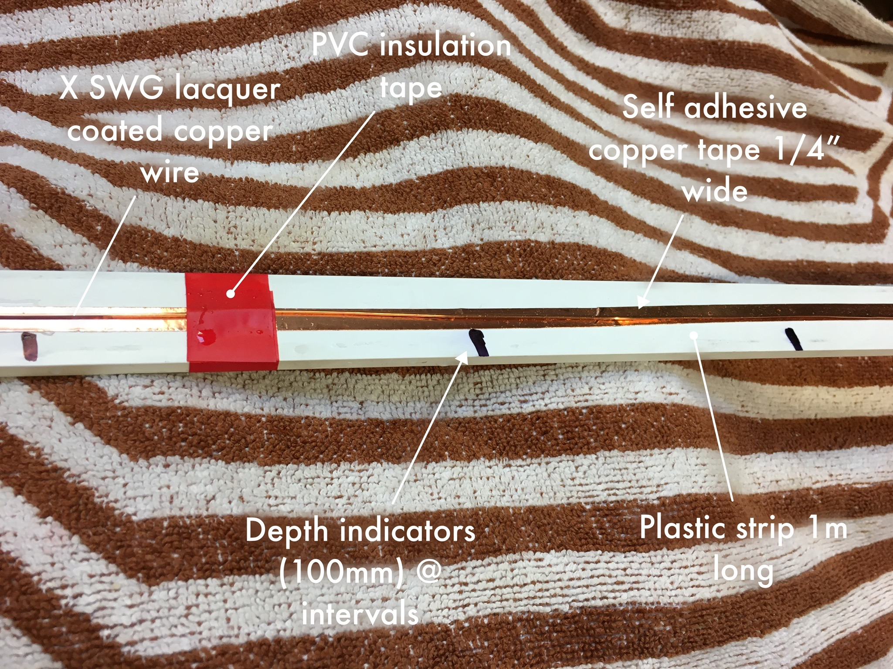

The copper tape is stuck to the plastic strip and lacquer covered copper wire laid (and later hot melt glued) on top.

The whole test set up looked like this:

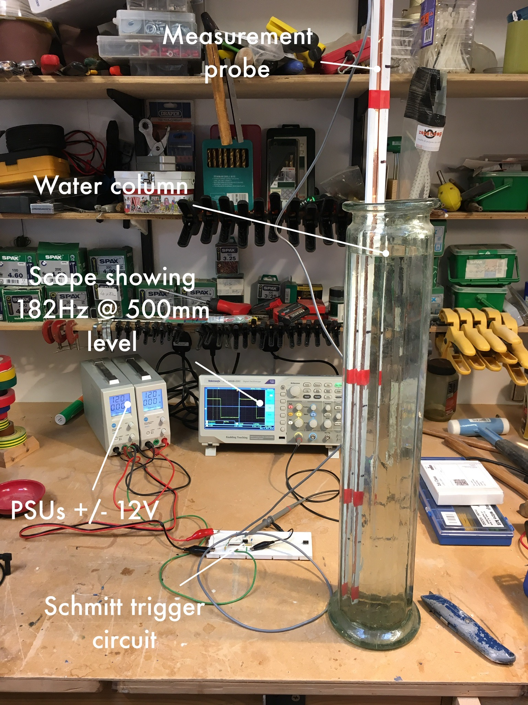

So enough of the build up what were the results?

First the test method:
- Note the frequency measurement with the water column empty
- Add water to the water column up to the first mark (100mm) not the frequency
- Add water up to the next mark, again not the frequency
- Repeat the process to the top mark (500mm)
- Remove the probe, empty the water column and repeat the process 3 times.

By the way the water used came out of a tap and was poured into the water column with the aid of a less than pristine garden watering can.

What I measured is shown in graphical form below:

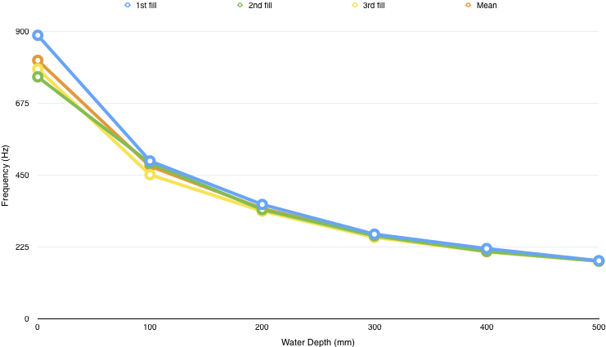

To be honest, for such a simple set-up, I was really quite impressed, especially with the way the measurements converged as the depth increased. It surely can’t be that easy?

I decided to explore measurement drift over time and to do this at a water depth of 100mm. The resulting measurments are in the table below:

Time | Measured Frequency
13:02 | 488Hz
14:08 | 491Hz
14:58 | 500Hz
16:27 | 538Hz
17:48 | 598Hz
20:31 | 637Hz

Ignoring other potential effects for a moment the increase in frequency points to a decrease in capacitance. I have suspicions that there may be some (electrical) leakage from the end of my wire electrode, I will make some changes to the probe to try to eliminate that problem and repeat the experiment. The change will increase the probe capacitance, which should mean that I can boost the ouptput frequency a little and increase the feedback current to improve noise immunity.

I also want to:
- replace the copper tape with aluminium as copper is not very nice for aquatic organisms.
- replace the OpAmp (a venerable 741) with a single rail device so the circuit will work off +5V.

After I’ve made the changes and got the basic measurment probe working again I’d very much like to interface it to a suitable Pi and for you Terry / Hamish to knock up some code that would allow us to run longer term tests requiting less human intervention.

Considering the basic measurement technique, things I’ve thought of that we may need to investigate the effect of and deal with:

Atmospheric conditions / humidity
Temperature
Supply stability
Water quality

This is a first shot at a measurement method, very much work in progress.

